

Capstone Project Report
Report 4 – Software Design Document

– HoChiMinh, October 2026 –
I. Record of Changes 3
II. Software Design Document 4
1. System Design 4
1.1 System Architecture 4
Figure 1. System Architecture. 5
1.2 Package Diagram 5
2. Database Design 8
2.1 Database Relationship Diagram 9
3. Detailed Design 16
3.1. WF-01 Practice a debate with AI and receive a feedback report 16
This feature enables users to practice debating against an AI-powered opponent. The system manages debate sessions, participant turns, argument submissions, and AI-generated counterarguments. 16
3.1.1 Class Diagram 16
3.1.2 Sequence Diagram · Practice a debate with AI 18
3.1.2 Sequence Diagram · Evaluate the debate and view the feedback report 18
3.2 AI Rebuttal Coaching 19
3.2.1 Class Diagram 19
3.2.2 Sequence Diagram — In-Debate AI Rebuttal Coaching 19
3.3 Rubric Scoring and Feedback Report 20
3.3.1 Class Diagram 20
3.3.2 Sequence Diagram — Evaluate Debate Performance and Generate Feedback Report 20
3.3.3 Sequence Diagram — View Debate Evaluation and Feedback Report 21
3.4 Debater vs Debater with AI Judge 22
3.4.1 Class Diagram 22
3.4.2 Sequence Diagram — Create and Join Human vs Human Debate Session 22
3.4.3 Sequence Diagram — Submit Arguments, Manage Turns and Final AI Judge Decision 23
3.5 Debate Competition Management 24
3.5.1 Class Diagram 24
3.5.2 Sequence Diagram — Create Competition and Register Team 25
3.5.3 Sequence Diagram — Prepare and Start Competition Match 25
3.6 Credit Package Purchase via payOS 26
3.6.1 Class Diagram 26
3.6.2 Buy Credit Package via payOS – Sequence Diagram 27

I. Record of Changes
Date | A*  M, D | In charge | Change Description
*A - Added M - Modified D - Deleted

II. Software Design Document

1. System Design

1.1 System Architecture

ADPP is a web-based debate practice platform with three application roles: Debater, Organizer, and Administrator. The React/Vite/TypeScript client communicates through the YARP API Gateway to the .NET 8 SystemService and two independent Python FastAPI services (AI Opponent and AI Evaluator). SystemService supports debate practice, competition management, topics, token wallet/payment and administration. The AI services support opponent responses, evaluation, feedback and coaching. SQL Server is the primary structured store, while Redis is optional. Real-time transport and voice providers remain subject to implementation verification; therefore, they are not presented as independently deployed infrastructure components in Figure 1.

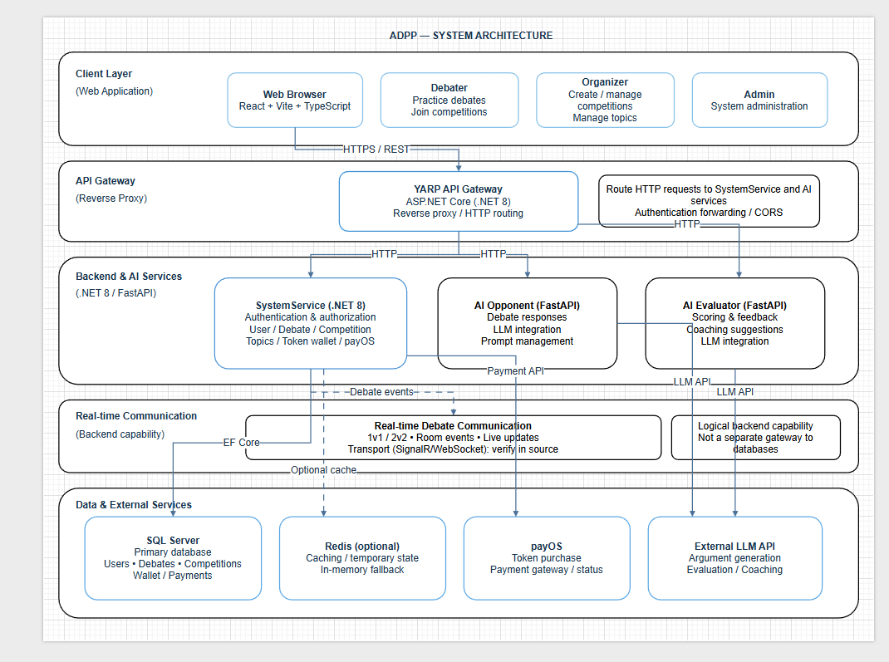

Figure 1. System Architecture.

1.2 Package Diagram
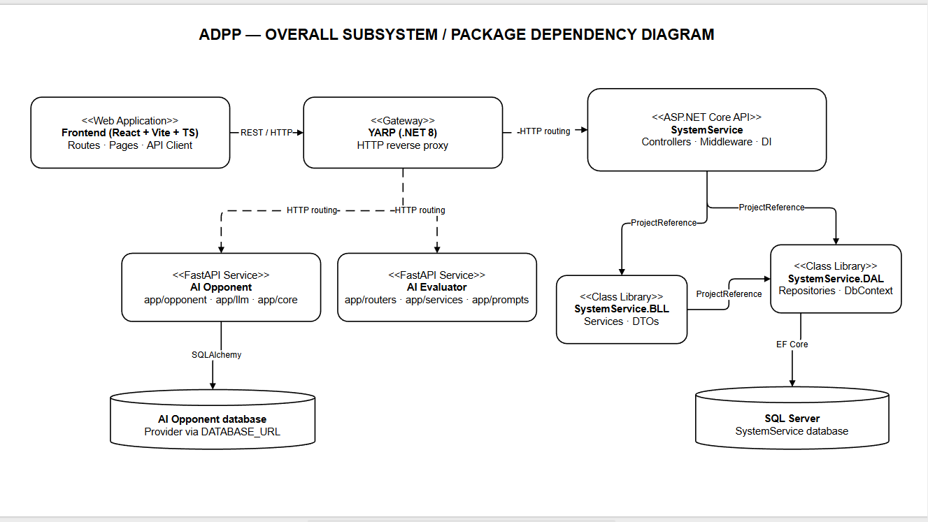
Figure 2. Overall Subsystem Dependency Diagram
1.2.1 Frontend Package Diagram
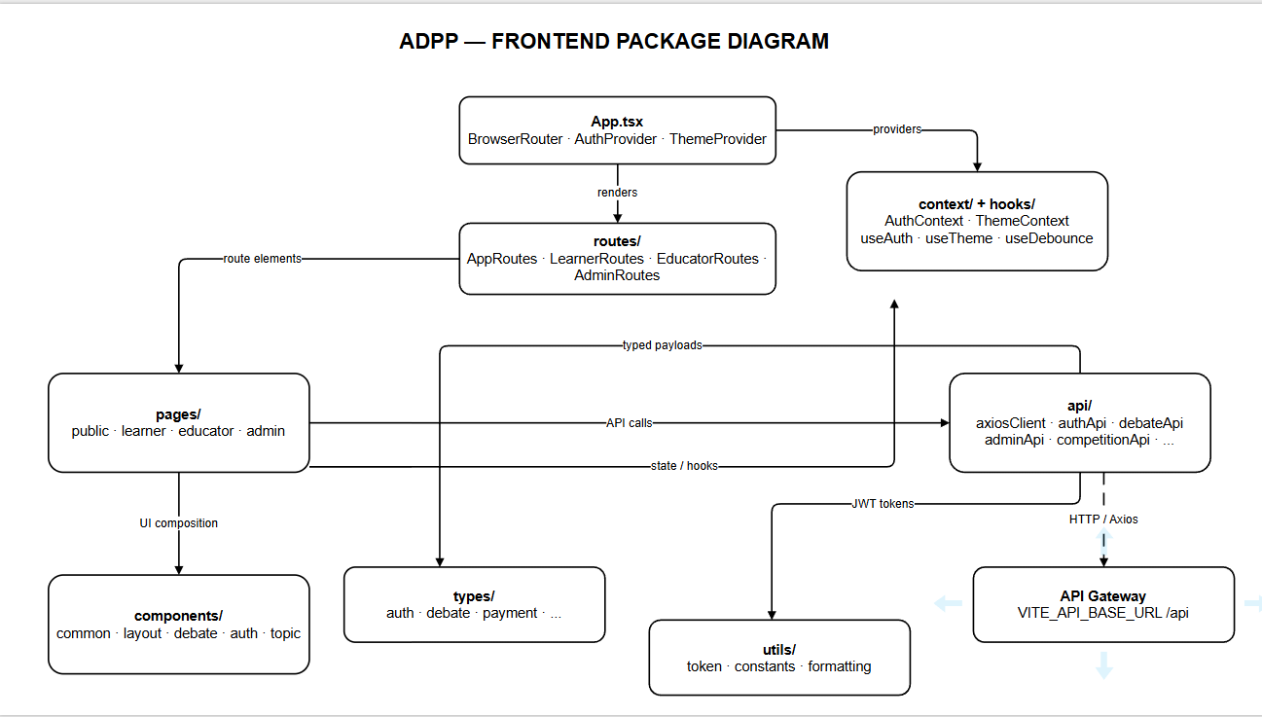

Figure 3. Frontend Package Diagram (React + Vite + TypeScript).
1.2.2 Backend Package Diagram

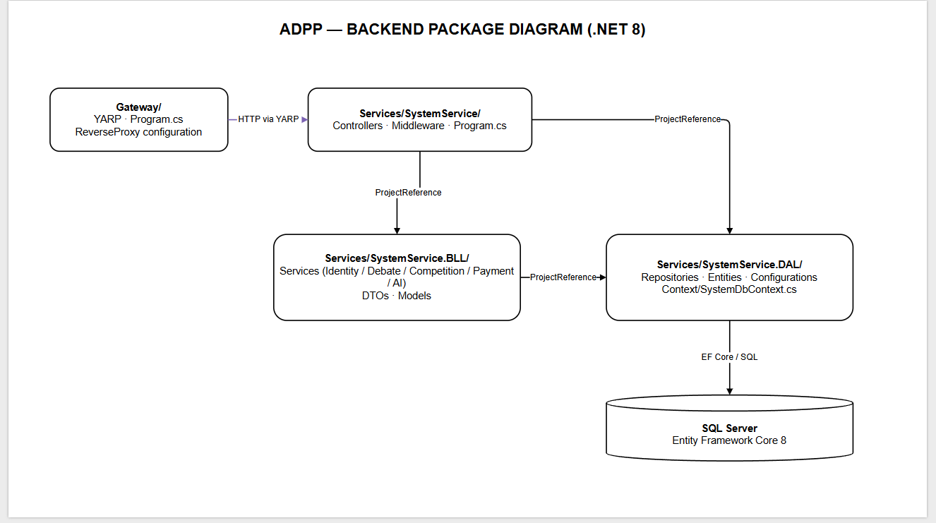Figure 4. Backend Package Diagram (.NET 8 and YARP).

1.2.3 AI Services Package Diagram
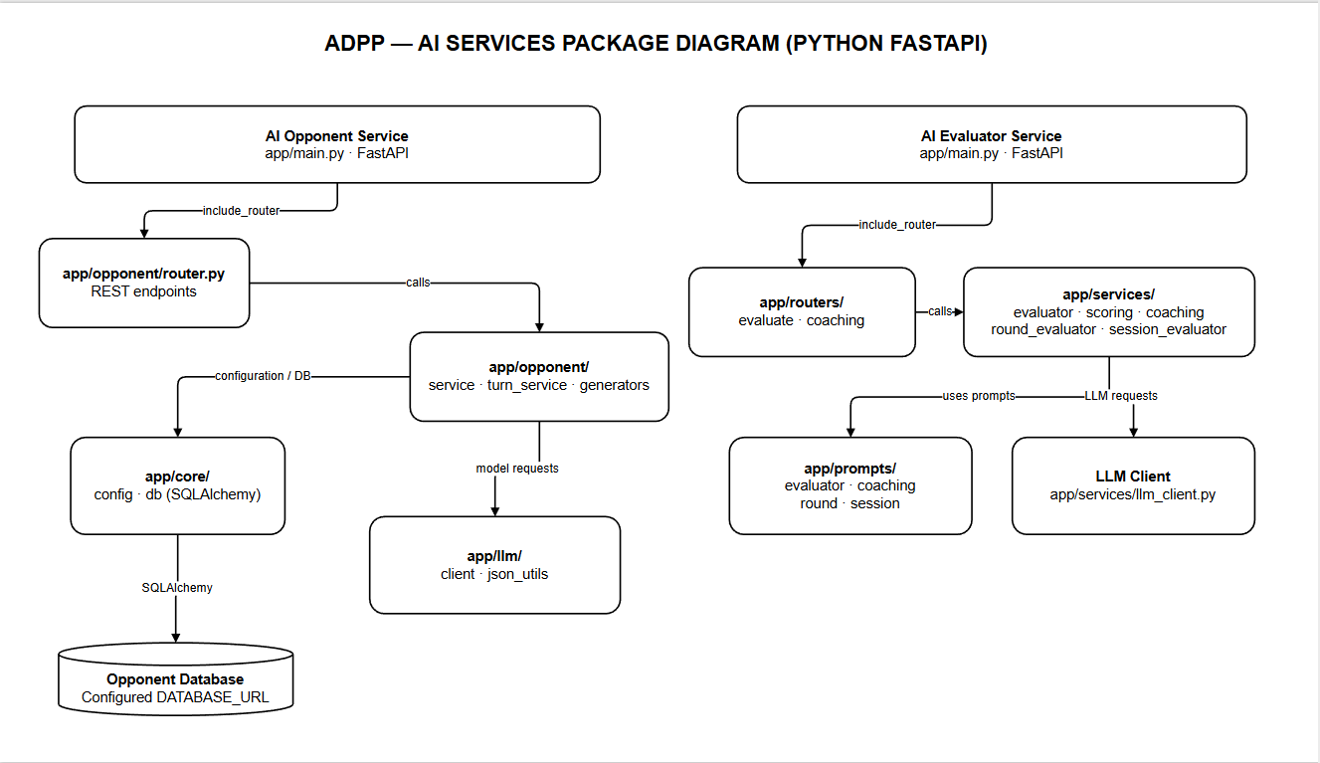
Figure 5. AI Opponent and AI Evaluator Package Diagram (Python FastAPI).
1.2.4 Package Descriptions

No | Package | Description
01 | Front-end-ADPP/src/routes | Defines client-side routing, protected routes, role-based authorization and navigation for Debater, Organizer and Admin screens.
02 | Front-end-ADPP/src/pages | Contains feature pages and screen-level UI.
03 | Front-end-ADPP/src/components | Provides reusable UI components.
04 | Front-end-ADPP/src/api | Contains frontend API integration code.
05 | Front-end-ADPP/src/context | Holds shared React context state.
06 | Front-end-ADPP/src/hooks | Contains reusable React hooks.
07 | Front-end-ADPP/src/types | Defines shared TypeScript types.
08 | Front-end-ADPP/src/utils | Provides shared utility functions.
09 | Gateway | ASP.NET Core YARP reverse proxy project for routing HTTP traffic.
10 | SystemService/Controllers | Contains backend REST API controllers.
11 | SystemService/Middleware | Contains ASP.NET Core request middleware.
12 | SystemService.BLL/Services | Implements application services and business workflows.
13 | SystemService.BLL/DTOs | Contains request and response data transfer objects.
14 | SystemService.BLL/Common | Contains shared BLL helpers and response structures.
15 | SystemService.BLL/Models | Contains BLL-level models.
16 | SystemService.DAL/Entities | Contains persistent data entities.
17 | SystemService.DAL/Repositories | Contains repository/data-access implementations.
18 | SystemService.DAL/Context | Contains the EF Core database context.
19 | SystemService.DAL/Configurations | Contains entity configurations.
20 | SystemService.DAL/Migrations | Contains database migration files.
21 | ai-opponent-service/app/opponent | Contains opponent routes, generation services, schemas and prompts.
22 | ai-opponent-service/app/llm | Contains LLM client and JSON helper modules.
23 | ai-opponent-service/app/core | Contains application configuration and database-related utilities for the AI Opponent service.
24 | ai-evaluator-service/app/routers | Defines API endpoints for AI debate evaluation and coaching.
25 | ai-evaluator-service/app/services | Contains evaluator, round/session evaluation and LLM integration modules.
26 | ai-evaluator-service/app/prompts | Contains evaluator prompt resources.

2. Database Design
Database scope: The five relationship diagrams and 43 table descriptions in this section follow the ADPP SQL schema supplied for this capstone. Subscription-related tables are documented as part of that physical schema; their presence does not establish subscription plans as an implemented or approved user-facing feature. Payment requirements in Report 3 focus on the prepaid token wallet and payOS.
The AI Debate Practice Platform (ADPP) uses Microsoft SQL Server as its relational database management system. The database stores user information, debate sessions, arguments, AI evaluation results, competition data, subscription plans, and payment transactions.

2.1 Database Relationship Diagram
The following diagrams illustrate the database tables, their primary keys (PK), foreign keys (FK), and relationships
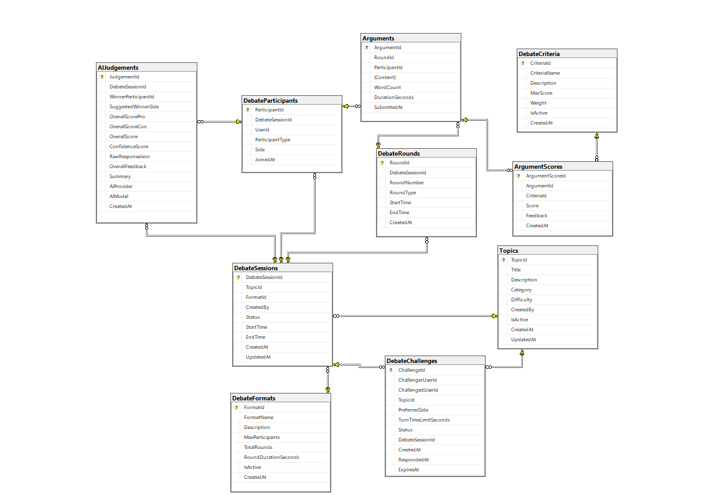
Figure 6. Identity and User Management Database Relationship Diagram.
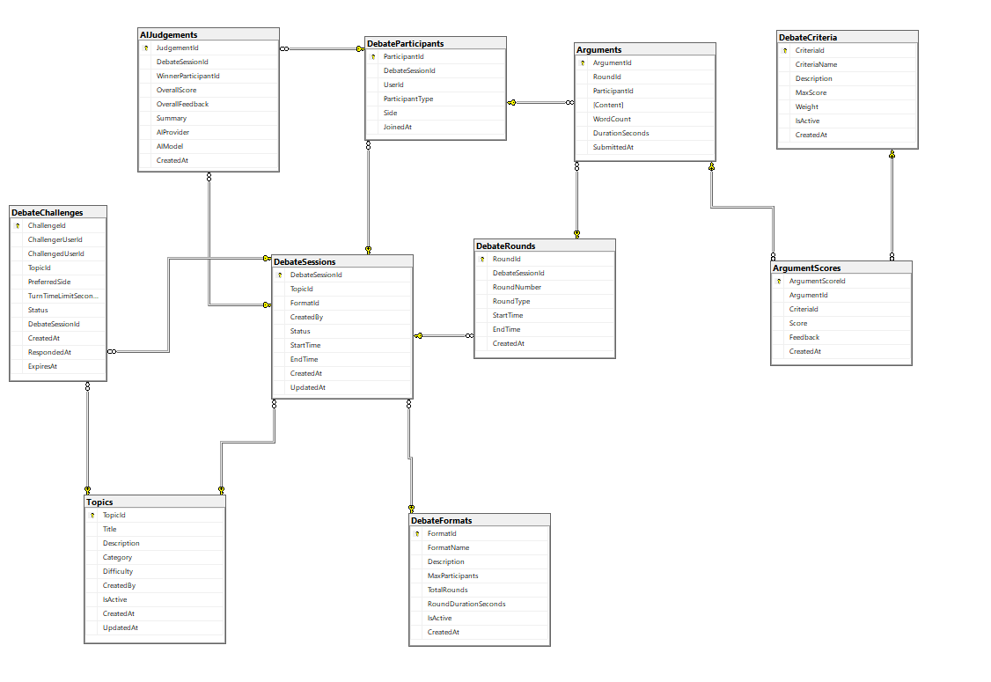
Figure 7: Debate Management Database Diagram
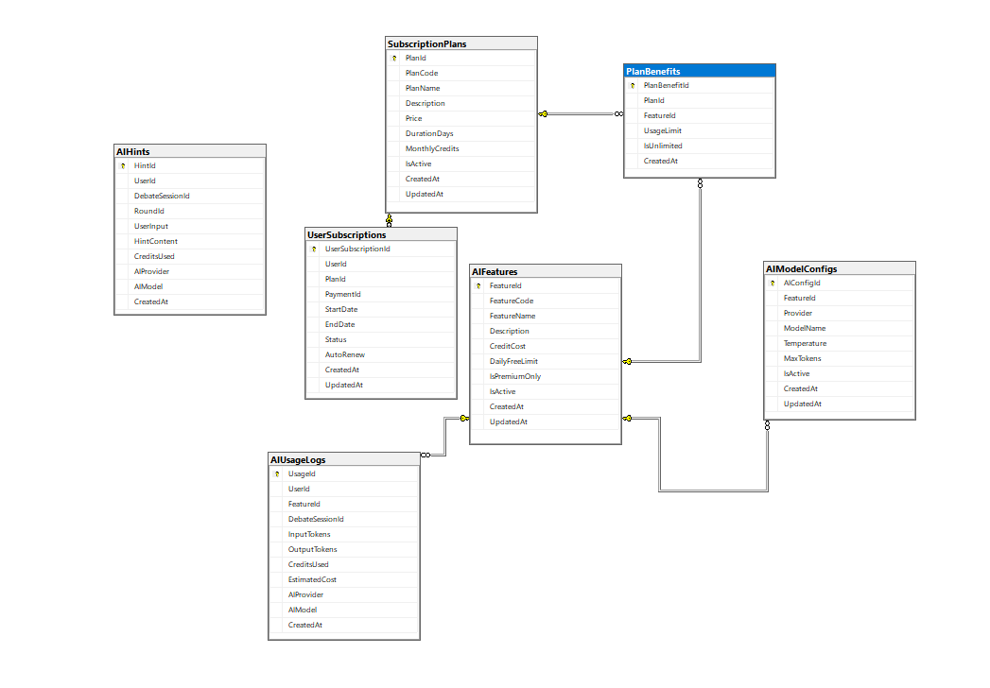
Figure 8: AI & Subscription Database Diagram
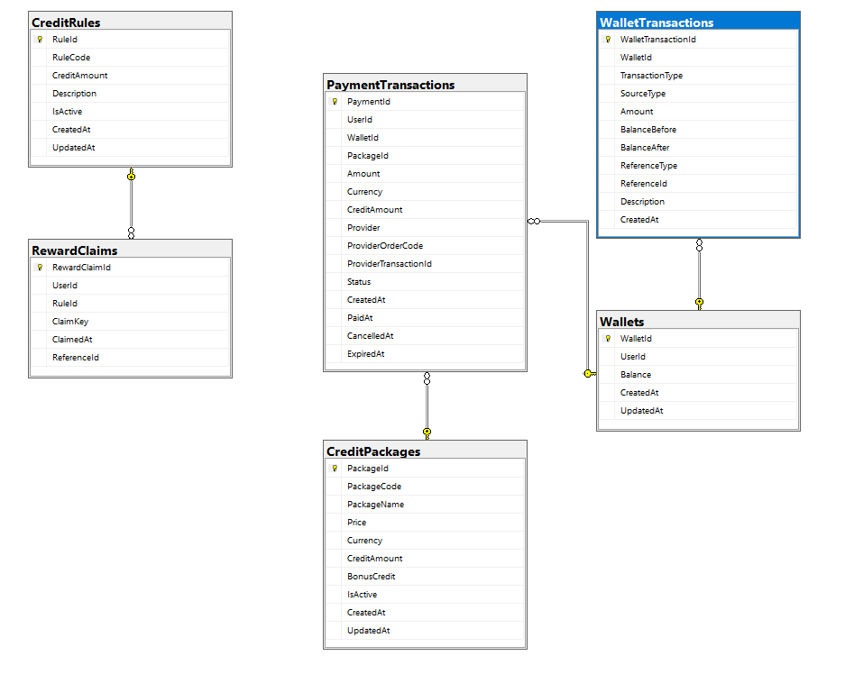Figure 9: Wallet & Payment Database Diagram
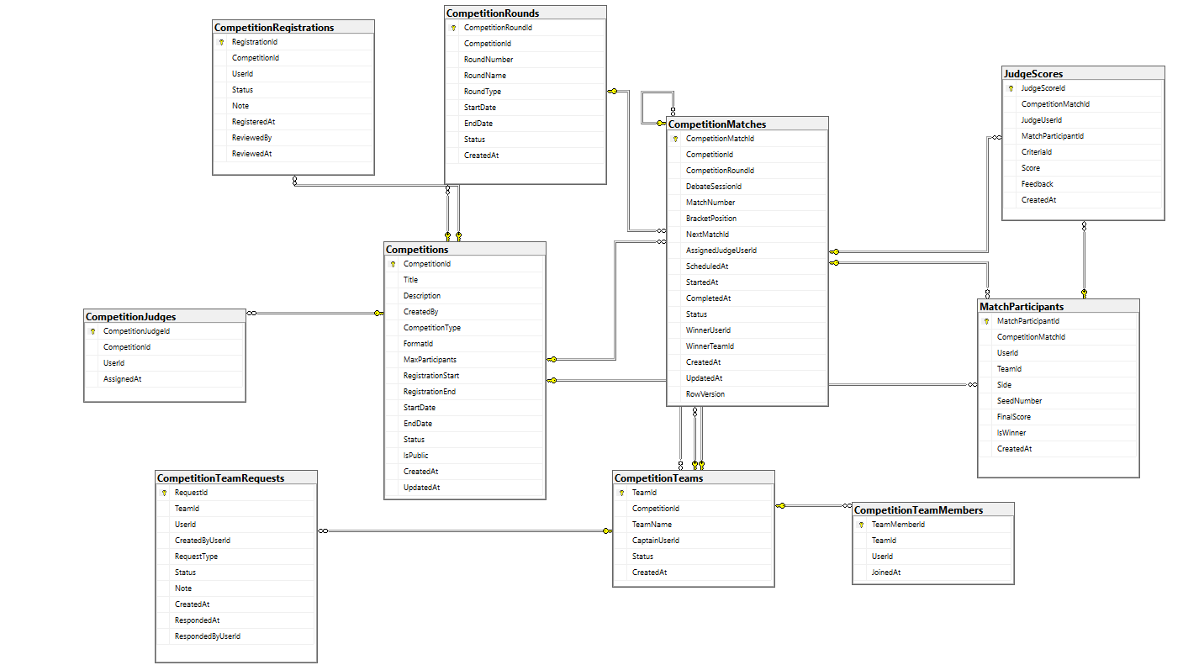Figure 10: Competition Management Database Diagram
Table Descriptions
No | Table | Description
01 | Roles | Stores the system roles used for role-based access control.  – Primary keys: RoleId  – Foreign keys: None
02 | Users | Stores registered user accounts, profile details, and account status.  – Primary keys: UserId  – Foreign keys: None
03 | RefreshTokens | Stores refresh tokens associated with user authentication sessions.  – Primary keys: Id  – Foreign keys: UserId → Users(UserId)
04 | UserRoles | Associates users with their assigned system roles.  Primary keys: UserId, RoleId.  Foreign keys: UserId → Users(UserId); RoleId → Roles(RoleId).
05 | UserStatistics | Tracks overall debate activity and performance statistics for each user.  – Primary keys: UserStatisticId  – Foreign keys: UserId → Users(UserId)
06 | SkillStatistics | Tracks user performance by debate evaluation criterion.  – Primary keys: SkillStatisticId  – Foreign keys: UserId → Users(UserId); CriteriaId → DebateCriteria(CriteriaId)
07 | Achievements | Defines achievements that users may earn.  – Primary keys: AchievementId  – Foreign keys: None
08 | UserAchievements | Records achievements unlocked by users.  – Primary keys: UserAchievementId  – Foreign keys: UserId → Users(UserId); AchievementId → Achievements(AchievementId)
09 | Notifications | Stores user-facing system notifications.  – Primary keys: NotificationId  – Foreign keys: UserId → Users(UserId)
10 | Reports | Records reports submitted by users and their review status.  – Primary keys: ReportId  – Foreign keys: ReportedBy → Users(UserId); ReviewedBy → Users(UserId)
11 | Topics | Stores available debate topics.  – Primary keys: TopicId  – Foreign keys: CreatedBy → Users(UserId)
12 | DebateFormats | Defines supported debate formats and round settings.  – Primary keys: FormatId  – Foreign keys: None
13 | DebateCriteria | Defines criteria used to evaluate debate performance.  – Primary keys: CriteriaId  – Foreign keys: None
14 | DebateSessions | Stores individual debate sessions and their lifecycle status.  – Primary keys: DebateSessionId  – Foreign keys: TopicId → Topics(TopicId); FormatId → DebateFormats(FormatId); CreatedBy → Users(UserId)
15 | DebateParticipants | Records participants in each debate session.  – Primary keys: ParticipantId  – Foreign keys: DebateSessionId → DebateSessions(DebateSessionId); UserId → Users(UserId)
16 | DebateRounds | Stores rounds belonging to debate sessions.  – Primary keys: RoundId  – Foreign keys: DebateSessionId → DebateSessions(DebateSessionId)
17 | Arguments | Stores arguments submitted by debate participants.  – Primary keys: ArgumentId  – Foreign keys: RoundId → DebateRounds(RoundId); ParticipantId → DebateParticipants(ParticipantId)
18 | DebateChallenges | Records debate challenges between users.  – Primary keys: ChallengeId  – Foreign keys: ChallengerUserId → Users(UserId); ChallengedUserId → Users(UserId); TopicId → Topics(TopicId); DebateSessionId → DebateSessions(DebateSessionId)
19 | AIJudgements | Stores AI-generated judgments and feedback for debate sessions.  – Primary keys: JudgementId  – Foreign keys: DebateSessionId → DebateSessions(DebateSessionId); WinnerParticipantId → DebateParticipants(ParticipantId)
20 | ArgumentScores | Stores scores and feedback for arguments against evaluation criteria.  – Primary keys: ArgumentScoreId  – Foreign keys: ArgumentId → Arguments(ArgumentId); CriteriaId → DebateCriteria(CriteriaId)
21 | AIFeatures | Defines AI features available in the platform.  – Primary keys: FeatureId  – Foreign keys: None
22 | AIModelConfigs | Stores configuration settings for AI models associated with features.  – Primary keys: AIConfigId  – Foreign keys: FeatureId → AIFeatures(FeatureId)
23 | AIHints | Stores AI-generated hints for users during debates.  – Primary keys: HintId  – Foreign keys: UserId → Users(UserId); DebateSessionId → DebateSessions(DebateSessionId); RoundId → DebateRounds(RoundId)
24 | AIUsageLogs | Records usage and cost-related information for AI features.  – Primary keys: UsageId  – Foreign keys: UserId → Users(UserId); FeatureId → AIFeatures(FeatureId); DebateSessionId → DebateSessions(DebateSessionId)
25 | SubscriptionPlans | Defines subscription plans and their pricing.  – Primary keys: PlanId  – Foreign keys: None
26 | PlanBenefits | Defines the AI feature benefits and limits of subscription plans.  – Primary keys: PlanBenefitId  – Foreign keys: PlanId → SubscriptionPlans(PlanId); FeatureId → AIFeatures(FeatureId)
27 | UserSubscriptions | Records subscription plans assigned to users.  – Primary keys: UserSubscriptionId  – Foreign keys: UserId → Users(UserId); PlanId → SubscriptionPlans(PlanId); PaymentId → PaymentTransactions(PaymentId)
28 | Wallets | Stores user wallet balances and related account information.  – Primary keys: WalletId  – Foreign keys: UserId → Users(UserId)
29 | WalletTransactions | Records credit transactions associated with wallets.  – Primary keys: WalletTransactionId  – Foreign keys: WalletId → Wallets(WalletId)
30 | CreditPackages | Defines purchasable credit packages.  – Primary keys: PackageId  – Foreign keys: None
31 | PaymentTransactions | Records payment transactions and processing status.  – Primary keys: PaymentId  – Foreign keys: UserId → Users(UserId); WalletId → Wallets(WalletId); PackageId → CreditPackages(PackageId)
32 | CreditRules | Defines rules for earning or consuming platform credits.  – Primary keys: RuleId  – Foreign keys: None
33 | RewardClaims | Records users' claims for platform rewards.  – Primary keys: RewardClaimId  – Foreign keys: UserId → Users(UserId); RuleId → CreditRules(RuleId)
34 | Competitions | Stores competition definitions, schedules, and status.  – Primary keys: CompetitionId  – Foreign keys: CreatedBy → Users(UserId); FormatId → DebateFormats(FormatId)
35 | CompetitionRegistrations | Records user registrations for competitions.  – Primary keys: RegistrationId  – Foreign keys: CompetitionId → Competitions(CompetitionId); UserId → Users(UserId); ReviewedBy → Users(UserId)
36 | CompetitionTeams | Stores teams participating in competitions.  – Primary keys: TeamId  – Foreign keys: CompetitionId → Competitions(CompetitionId); CaptainUserId → Users(UserId)
37 | CompetitionTeamMembers | Records membership of competition teams.  – Primary keys: TeamMemberId  – Foreign keys: TeamId → CompetitionTeams(TeamId); UserId → Users(UserId)
38 | CompetitionTeamRequests | Records requests to join or manage competition teams.  – Primary keys: RequestId  – Foreign keys: TeamId → CompetitionTeams(TeamId); UserId → Users(UserId); CreatedByUserId → Users(UserId); RespondedByUserId → Users(UserId)
39 | CompetitionRounds | Defines rounds within competitions.  – Primary keys: CompetitionRoundId  – Foreign keys: CompetitionId → Competitions(CompetitionId)
40 | CompetitionJudges | Assigns judges to competitions.  – Primary keys: CompetitionJudgeId  – Foreign keys: CompetitionId → Competitions(CompetitionId); UserId → Users(UserId)
41 | CompetitionMatches | Stores competition matches, bracket positions, assigned judges, progression to subsequent matches, and match outcomes.  Primary keys: CompetitionMatchId.  Foreign keys: CompetitionId → Competitions(CompetitionId); CompetitionRoundId → CompetitionRounds(CompetitionRoundId); DebateSessionId → DebateSessions(DebateSessionId); WinnerUserId → Users(UserId); WinnerTeamId → CompetitionTeams(TeamId); NextMatchId → CompetitionMatches(CompetitionMatchId); AssignedJudgeUserId → Users(UserId).
42 | MatchParticipants | Records participants assigned to competition matches.  – Primary keys: MatchParticipantId  – Foreign keys: CompetitionMatchId → CompetitionMatches(CompetitionMatchId); UserId → Users(UserId); TeamId → CompetitionTeams(TeamId)
43 | JudgeScores | Records users or teams participating in competition matches, including their seed numbers, assigned sides, final scores, and winner status.  Primary keys: MatchParticipantId.  Foreign keys: CompetitionMatchId → CompetitionMatches(CompetitionMatchId); UserId → Users(UserId); TeamId → CompetitionTeams(TeamId).

3. Detailed Design

3.1. WF-01 Practice a debate with AI and receive a feedback report

This feature enables users to practice debating against an AI-powered opponent. The system manages debate sessions, participant turns, argument submissions, and AI-generated counterarguments.

3.1.1 Class Diagram
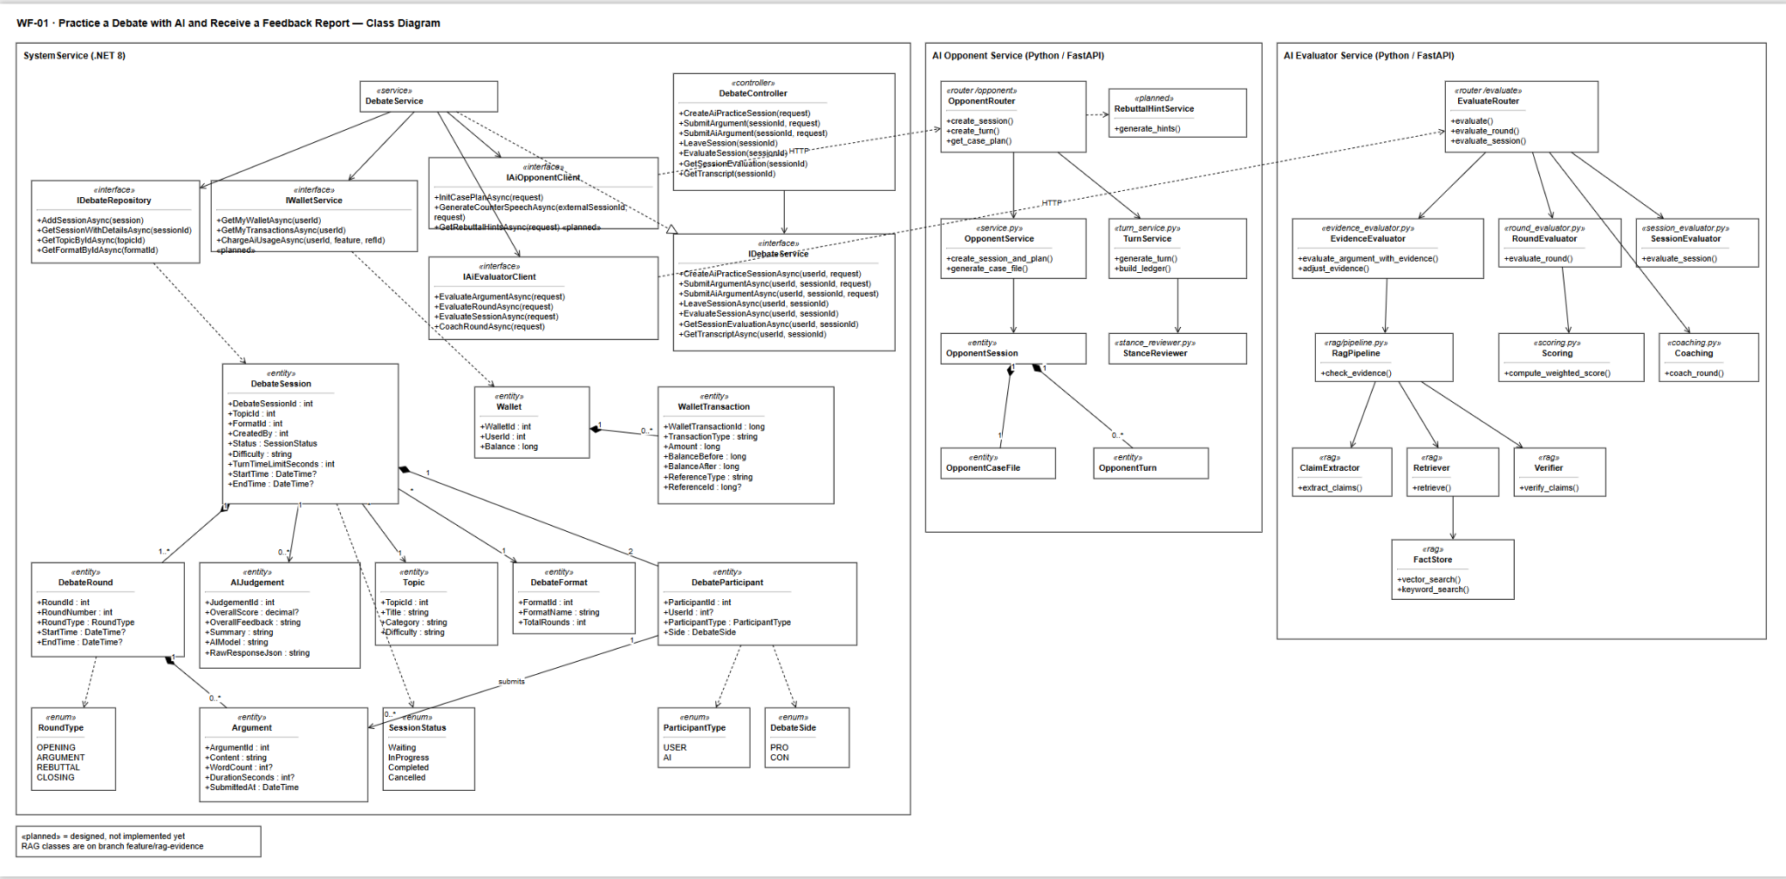

3.1.2 Sequence Diagram · Practice a debate with AI
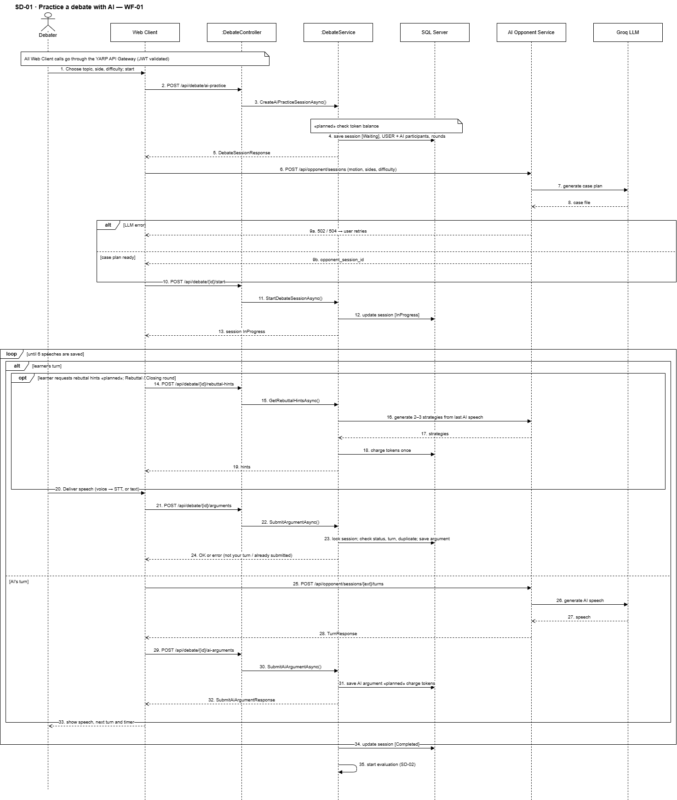

3.1.2 Sequence Diagram · Evaluate the debate and view the feedback report

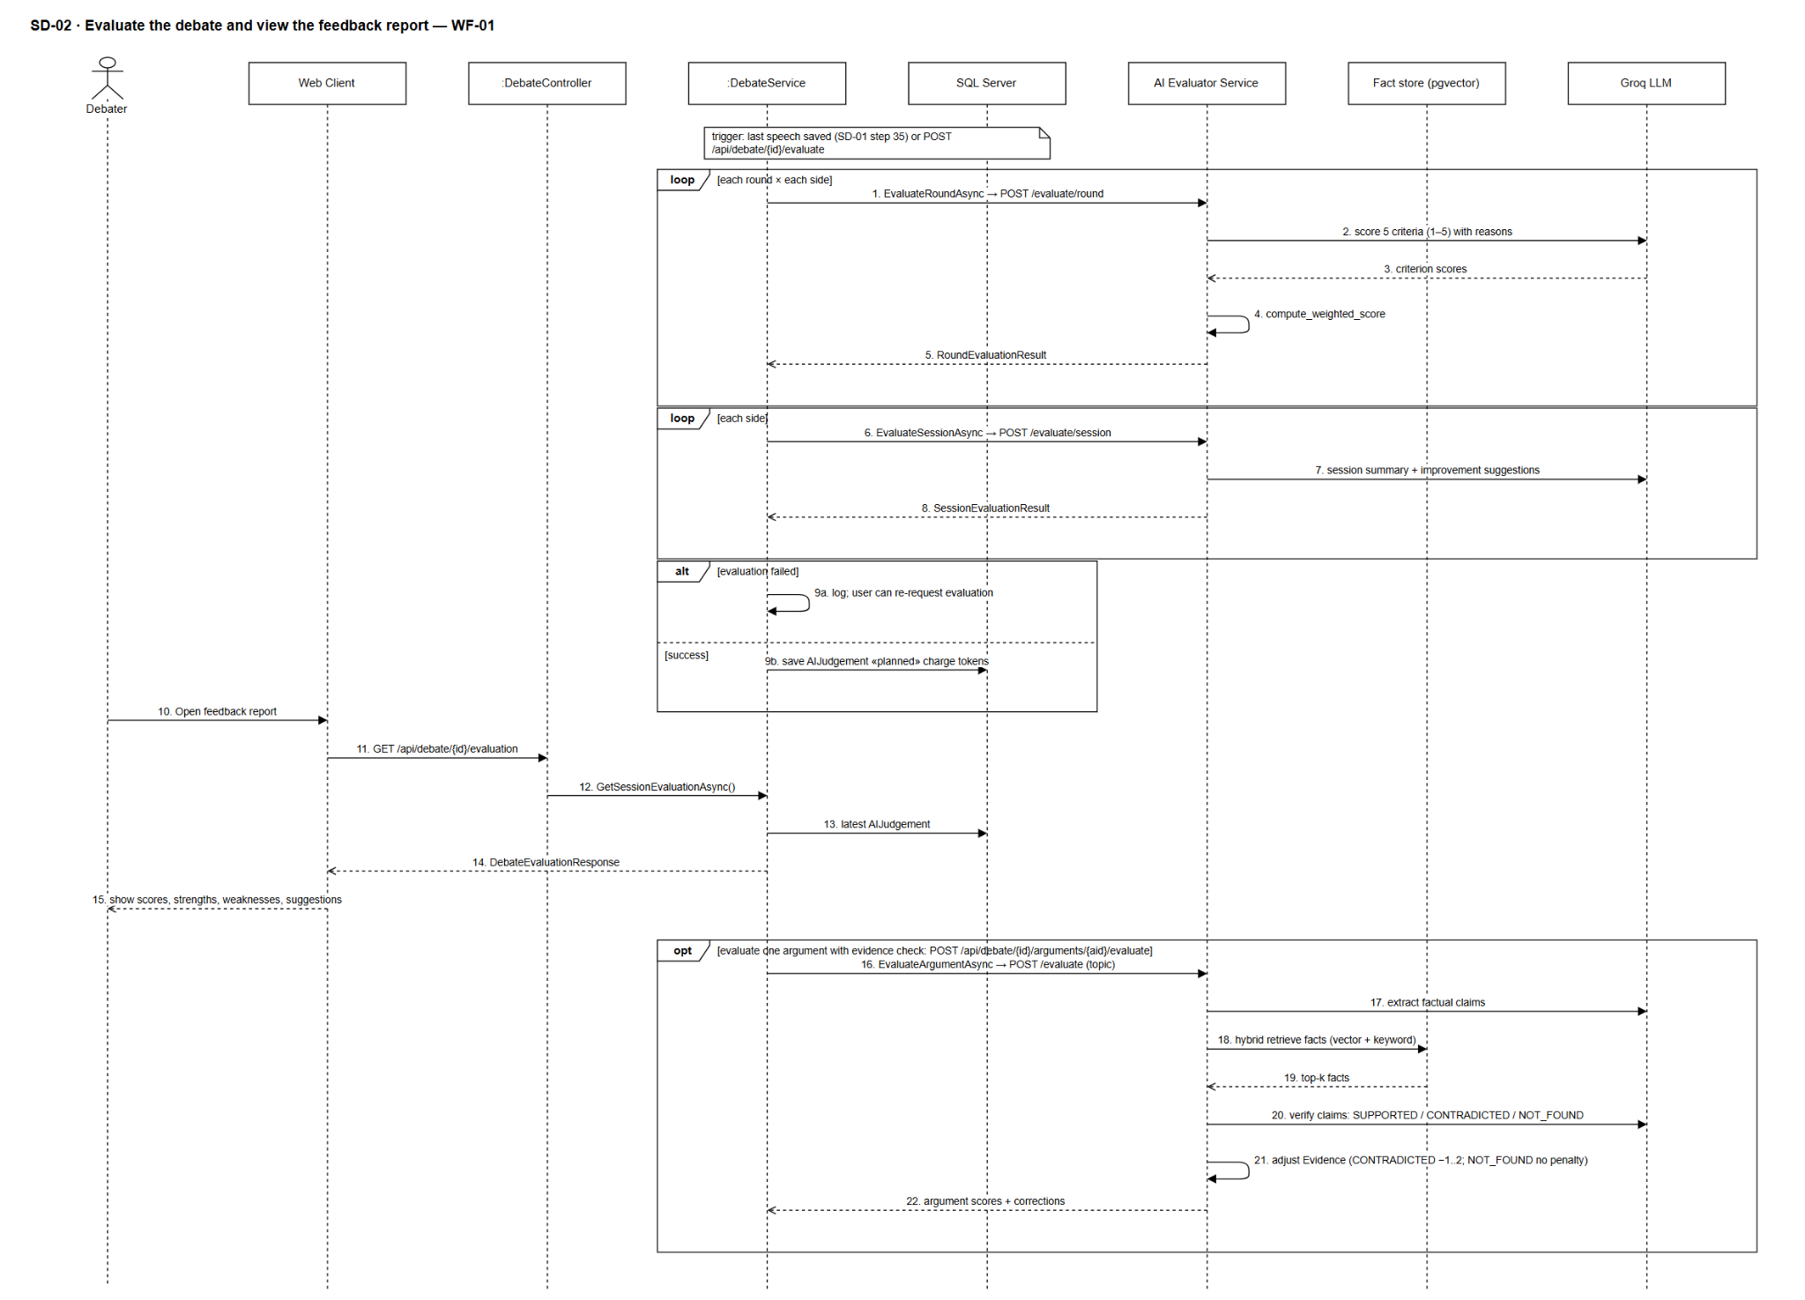

3.2 AI Rebuttal Coaching

3.2.1 Class Diagram

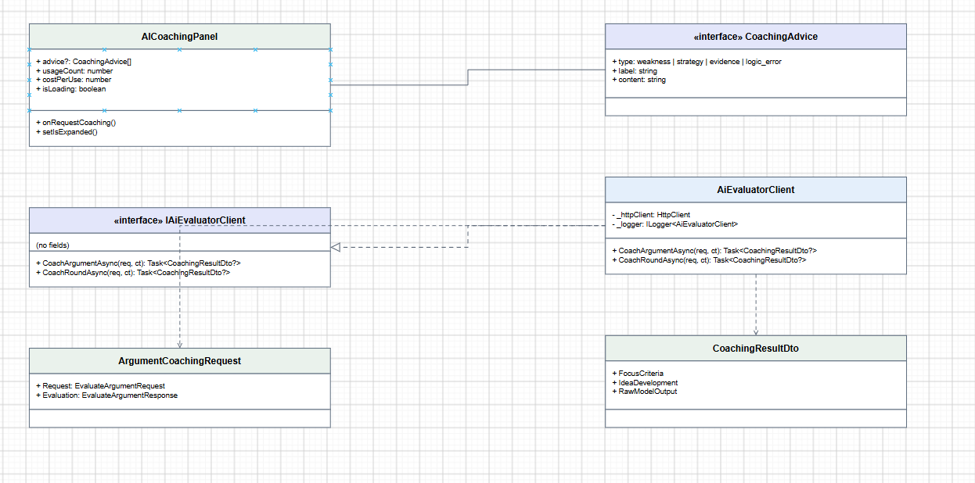

3.2.2 Sequence Diagram — In-Debate AI Rebuttal Coaching
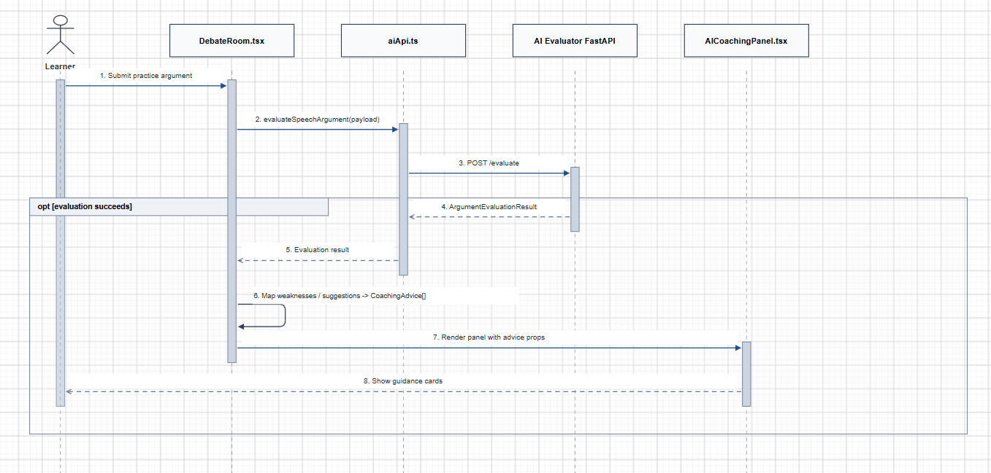

3.3 Rubric Scoring and Feedback Report

3.3.1 Class Diagram
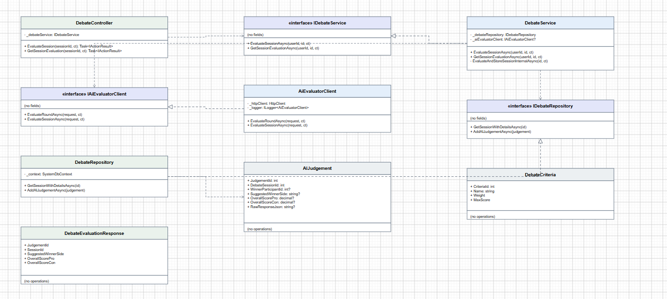

3.3.2 Sequence Diagram — Evaluate Debate Performance and Generate Feedback Report
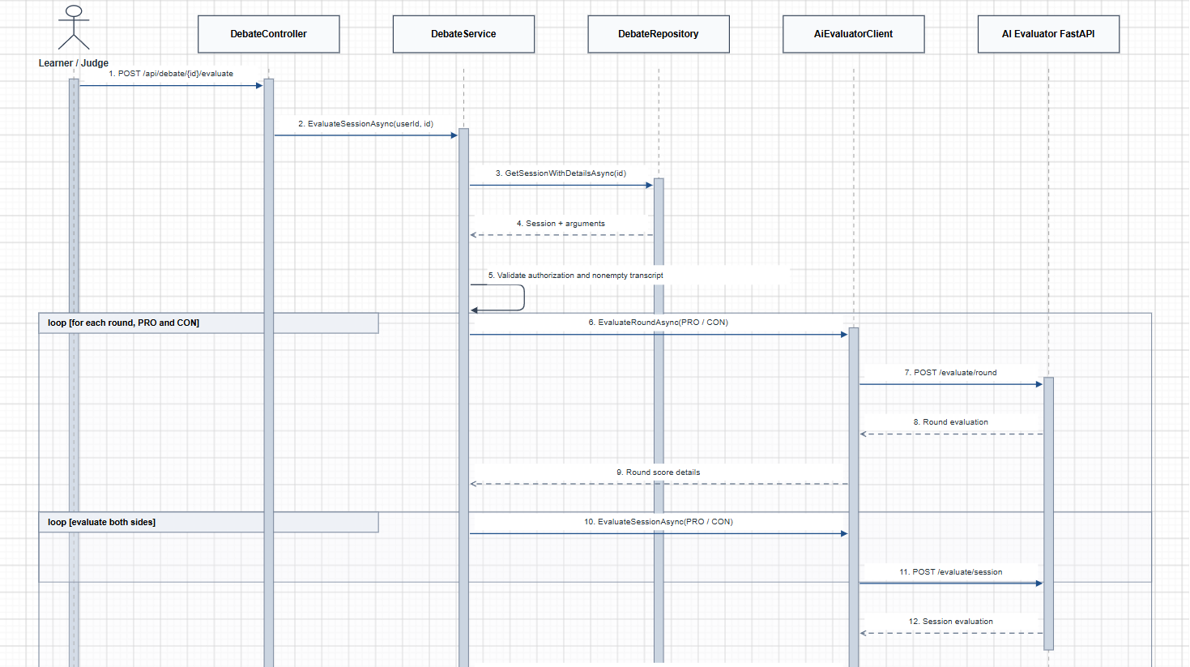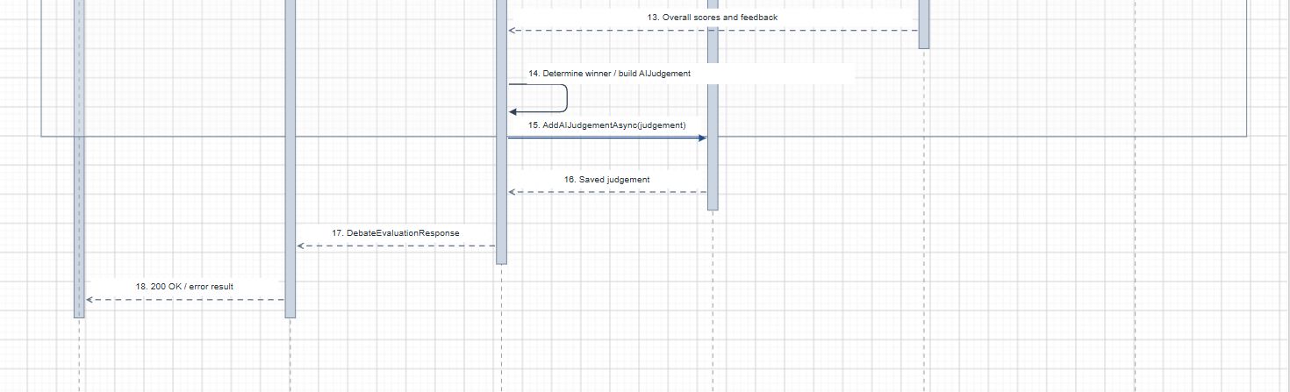

3.3.3 Sequence Diagram — View Debate Evaluation and Feedback Report
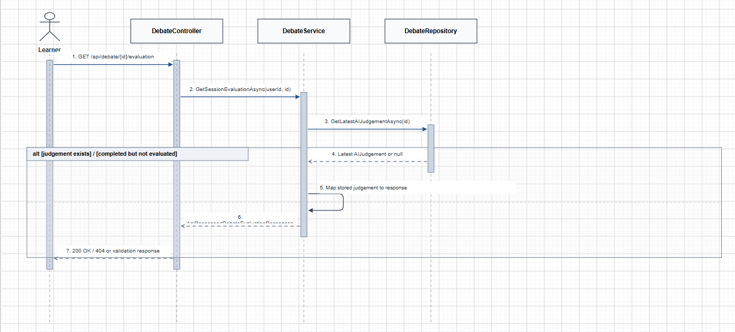

3.4 Debater vs Debater with AI Judge

3.4.1 Class Diagram
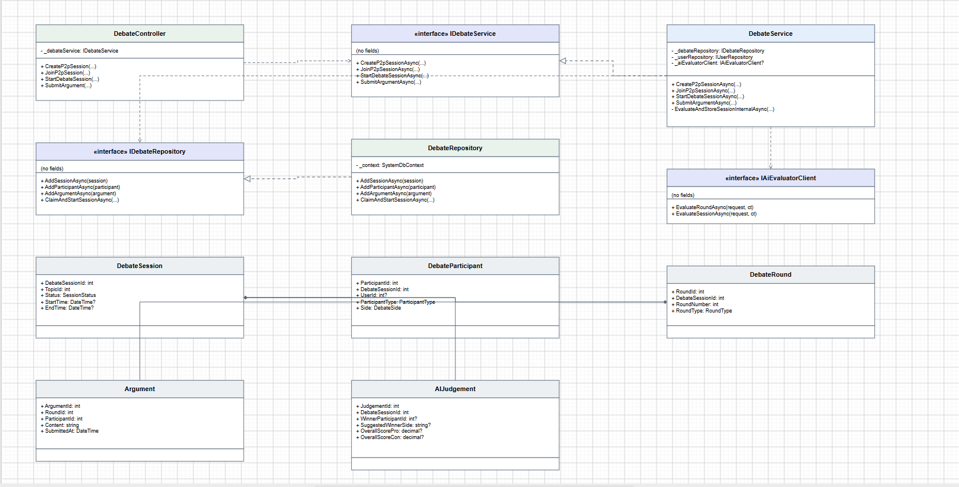

3.4.2 Sequence Diagram — Create and Join Human vs Human Debate Session
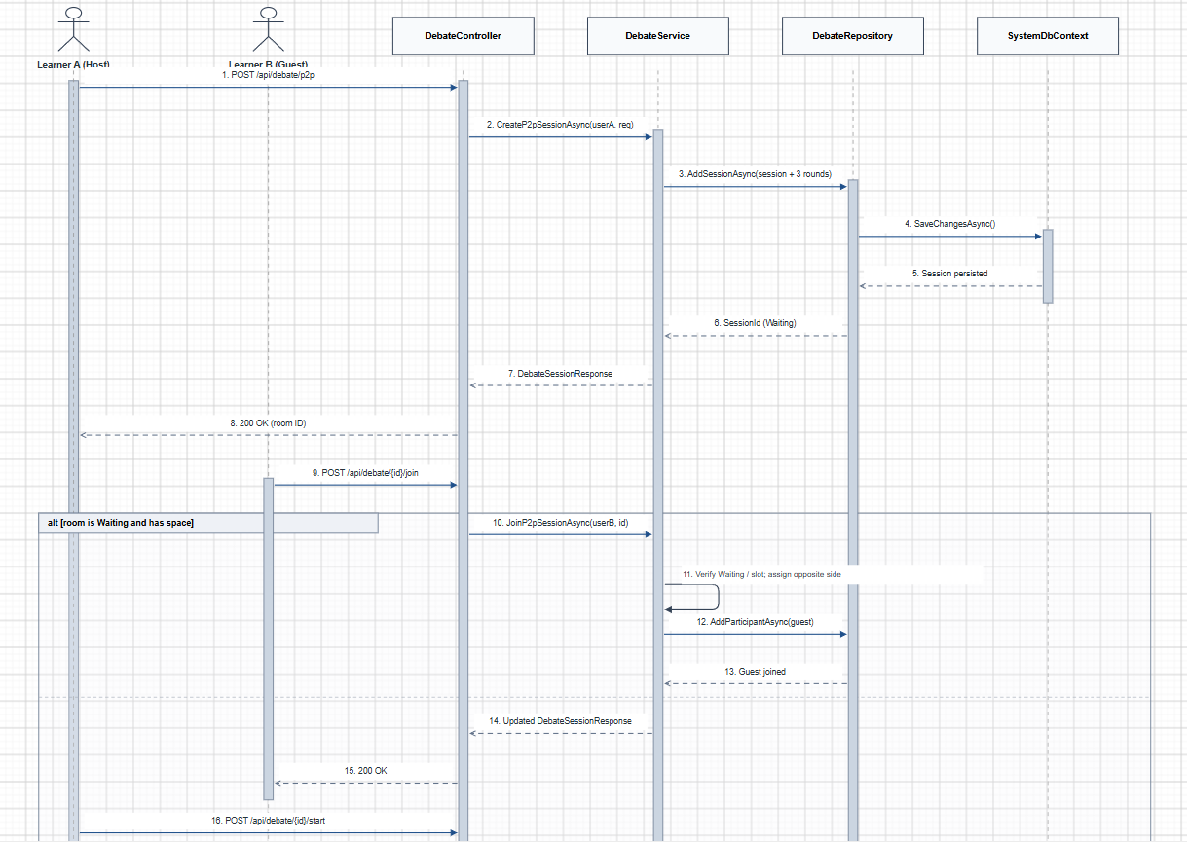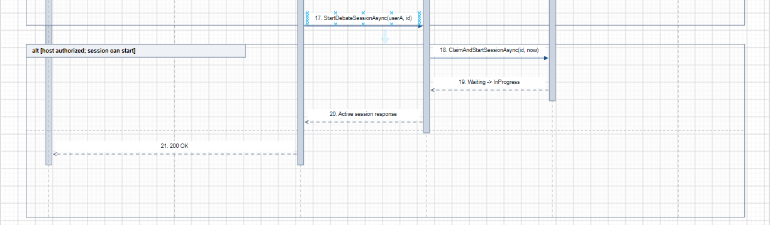

3.4.3 Sequence Diagram — Submit Arguments, Manage Turns and Final AI Judge Decision

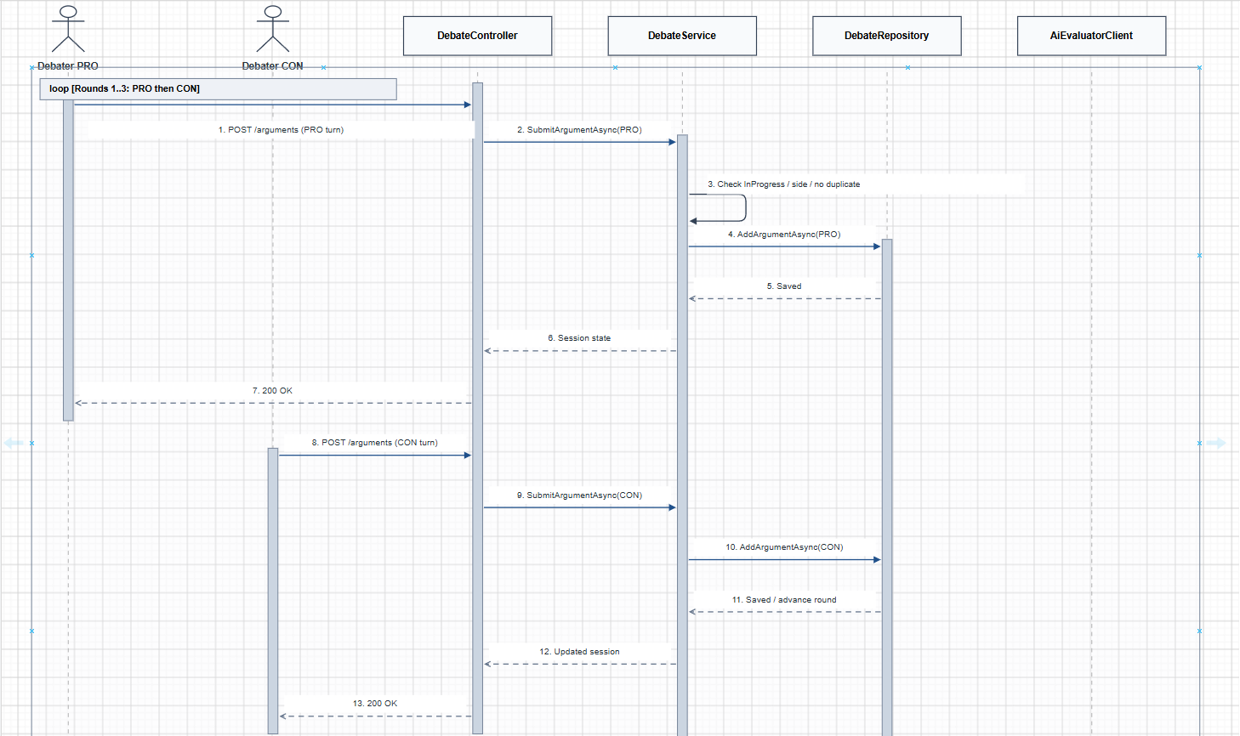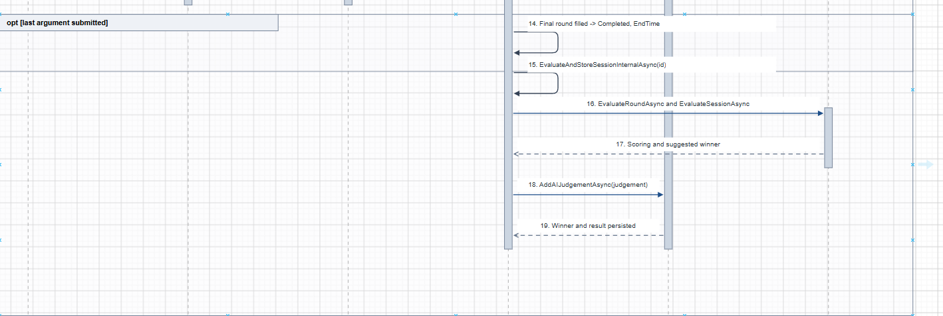

3.5 Debate Competition Management

3.5.1 Class Diagram
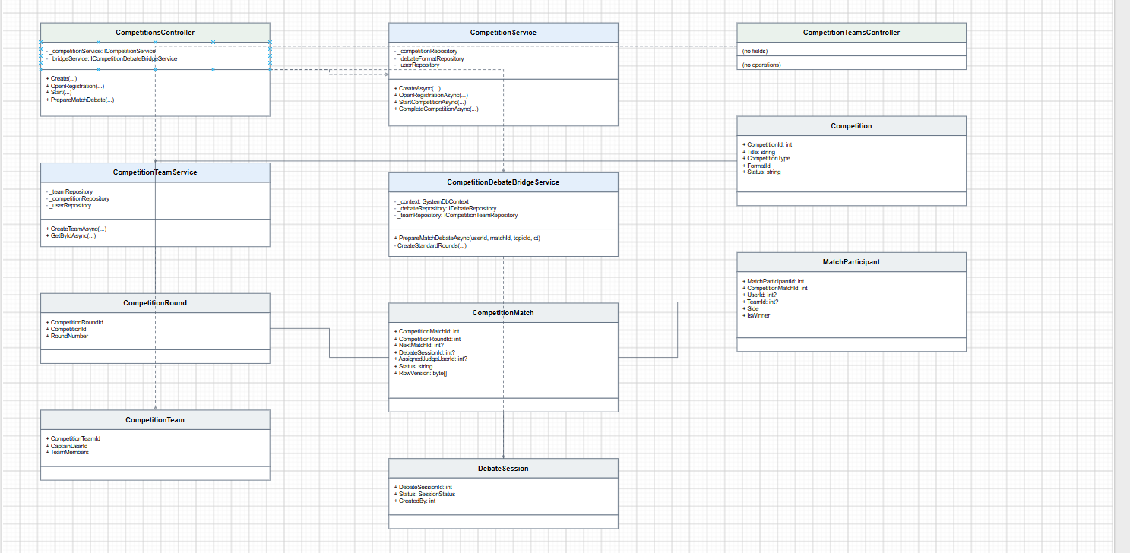

3.5.2 Sequence Diagram — Create Competition and Register Team
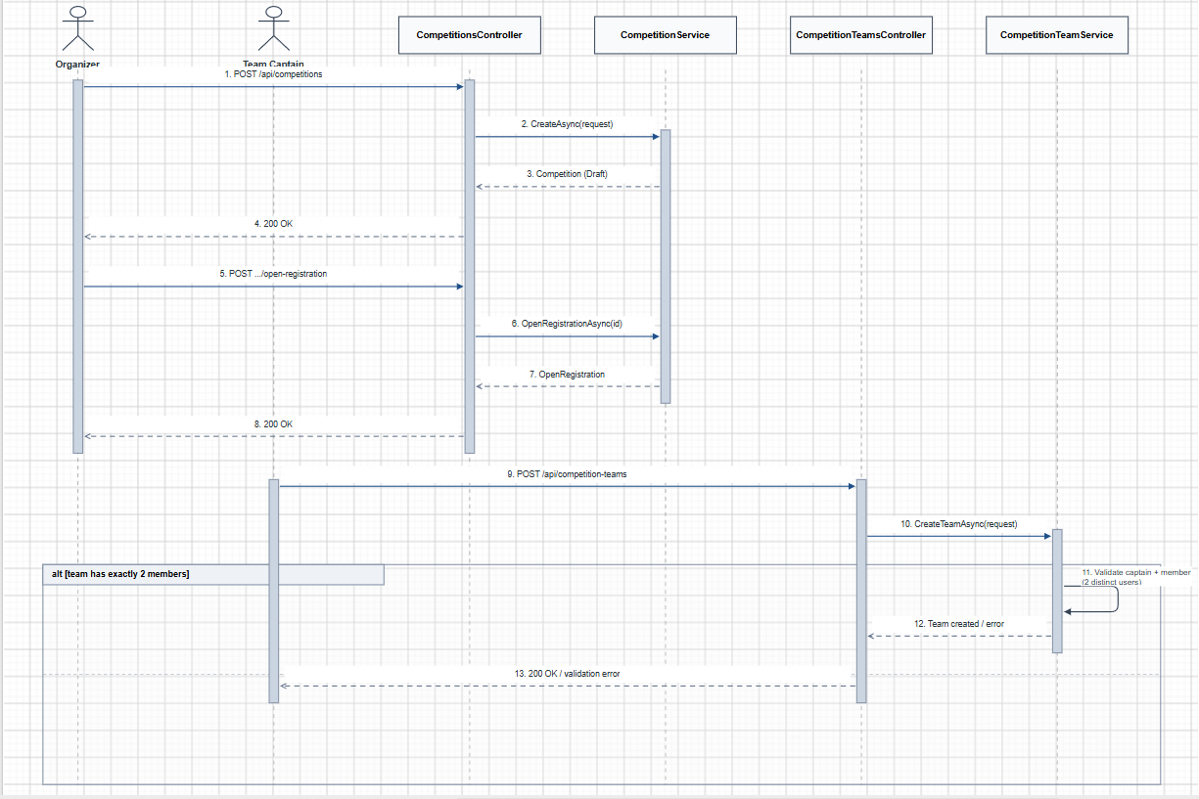

3.5.3 Sequence Diagram — Prepare and Start Competition Match
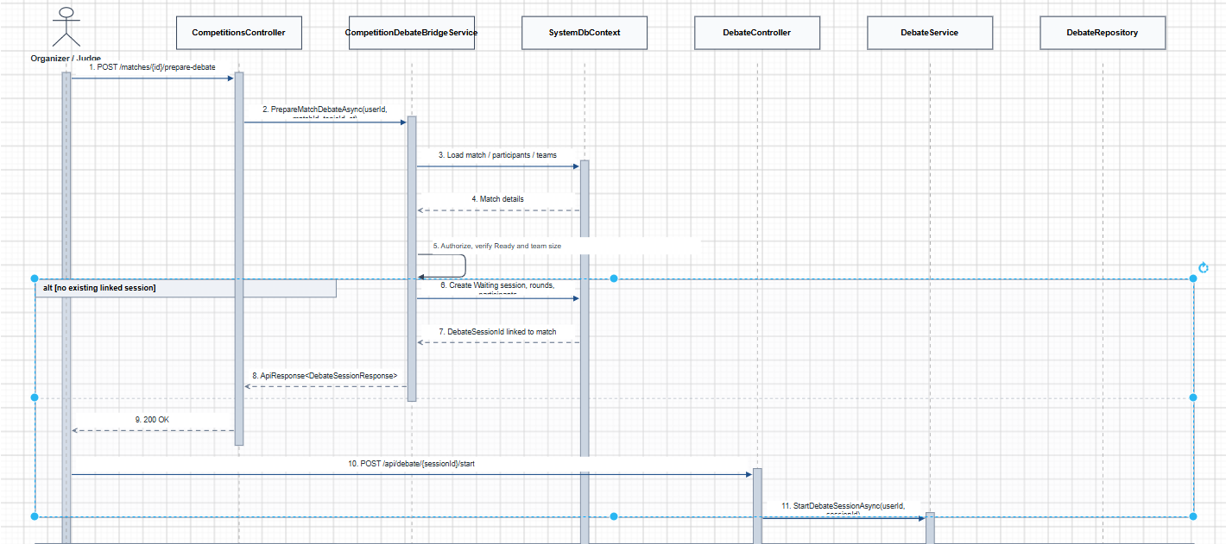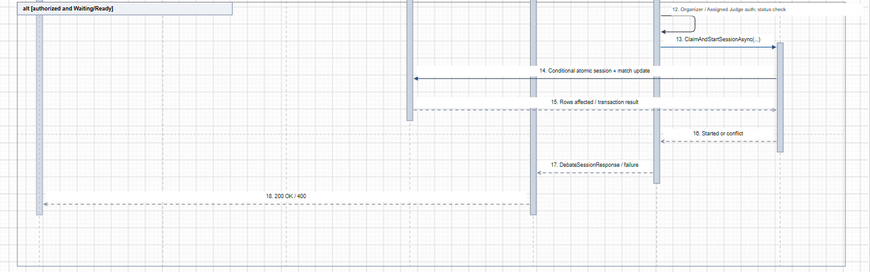

3.6 Credit Package Purchase via payOS

3.6.1 Class Diagram
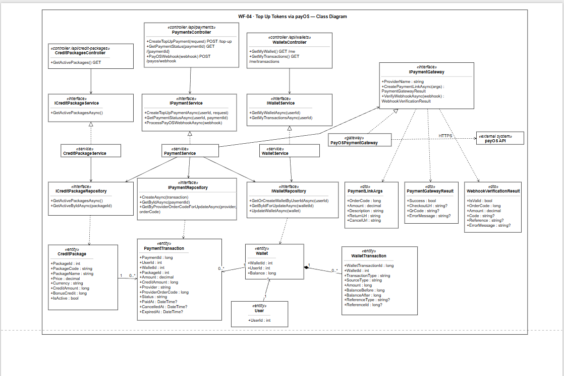

3.6.2 Buy Credit Package via payOS – Sequence Diagram


